Wacom for Windows/Mac
INSTALLATION
- Connect your Wacom using the USB port into tablet or computer
- For setting up the Wacom – visit https://www.wacom.com/en-us/getting-started/wacom-intuos were they have provided detailed instructions.
- Click on Windows/Mac for downloading drivers
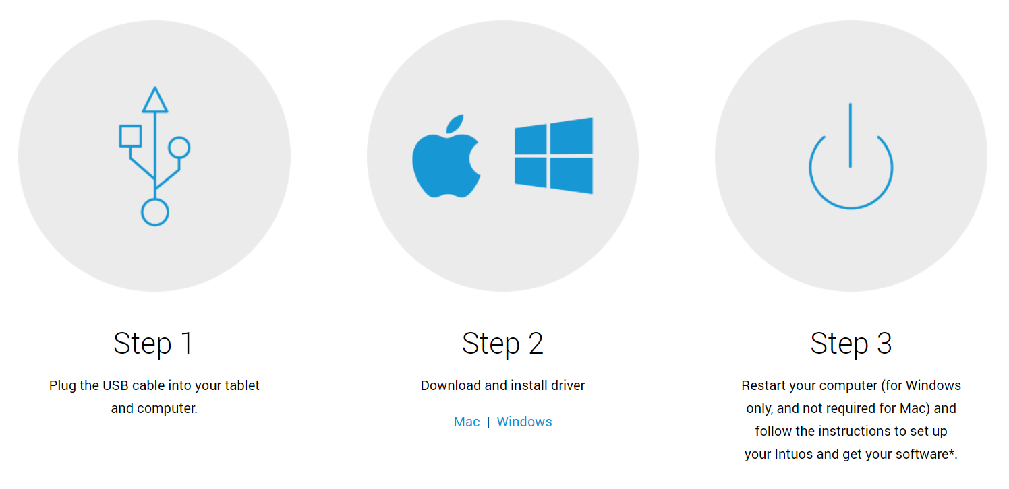
- Once downloaded, click on the application to install it.
- Once installed it will prompt user to restart the computer.
PAIR YOUR WACOM VIA BLUETOOTH TO COMPUTER
- Unplug your tablet
- Open Bluetooth settings/preference on your computer
- Press the power (middle) button of your Intuos and the Led will start blinking blue.
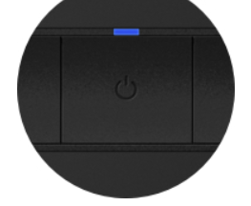

- On your computer, select Wacom Intuos and “Pair”
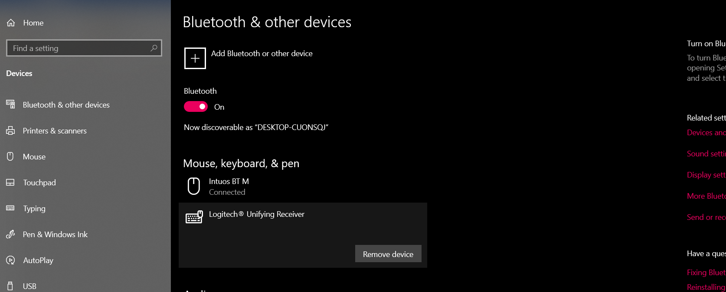

SET UP WACOM

After Installing drivers, click on the driver, a prompt box appears. Select “Yes” to allow the application to make changes.

- A welcome window should open.
