Creating a Template on Bluescape

- Withing a workspace you may want to organize multiple canvases in the same way
To design a canvas hit the “+” icon, and click on “canvas.” From there you can place and upload different content within the canvas the way you’d like. Don’t forget to pin any items you want to stay in place!

- If you want to copy and paste the same canvas into the same wall simply hit “duplicate”
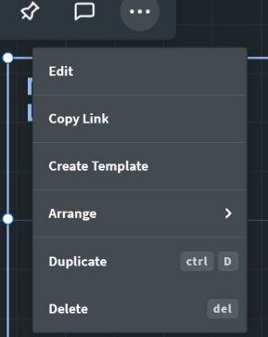
To duplicate the canvas in the same wall click the square in the top left corner of the canvas you want to duplicate and you should see a horizontal option menu above it. Click the three dots to the far right and click “Duplicate” from the drop down. This will essentially copy and paste that same canvas next to the original canvas.
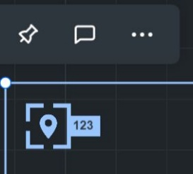

- To duplicate a canvas and put it into a different workspace you need to create a template of that canvas.
If you want to use a canvas from one workspace and copy the same format into a different one you will need to create a template of that canvas. To do this:
Click the square in the top left corner, and again click the three dots from the menu.
On the dropdown instead of duplicate, click “Create Template”
Bluescape will give you options to name, describe, share, and recolor the template.
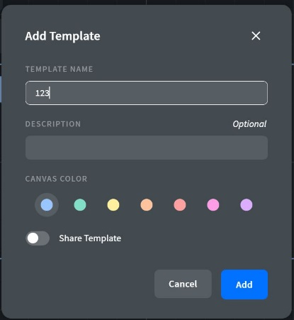

- Add the newly created template into a different workspace
Go into the workspace you’d like to add the template into and click “+” and “Template”
This will pull up options of the custom templates you created. (To see Bluescape’s templates change the filter from “custom”)

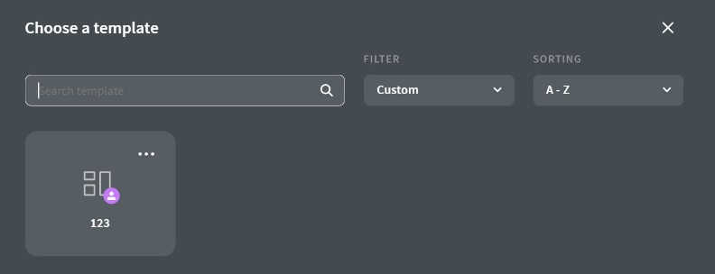

- Sharing a pre created template with someone
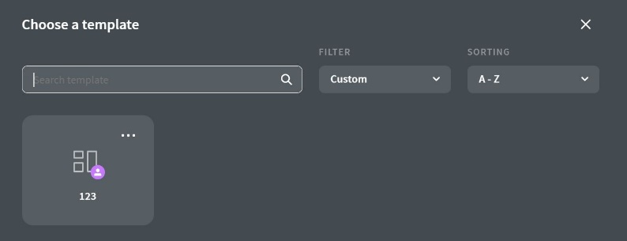
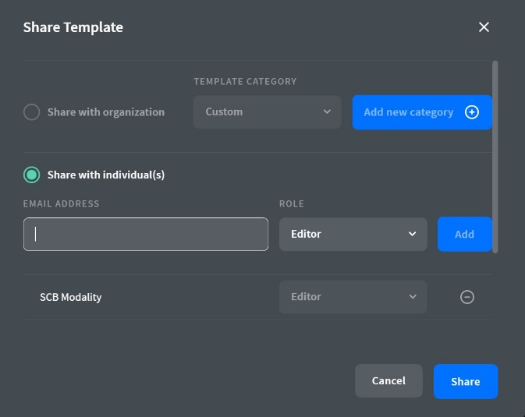
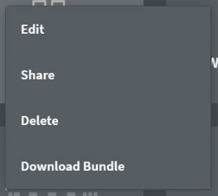
When you want to share the custom template you created, go to the “+” as if you were going to add the template into the workspace, however when you get to the template option page find the one you’d like to share and click the three dots at the top right corner of it. This will give you a drop down, select “share”. It will pull up a place to put the email of the user you’d like to share it with, or an organization if you want to make your template more public.

- Extra Tip
If you want to create a template of a canvas that already has content uploaded into it first delete the content out so that your template is a layout. This will be quicker than deleting the content out of each template one by one as you reuse it. Additionally, it is important to delete content out if you are sharing the canvas, you don’t want to share a canvas with student documents in it.

