NAME______________________
Lesson 6A
Spelling Test – Fill in the missing letters for the correct spelling of each word below.

- _u_ _ _
- _ _ui_
- a_ _ue
- _ _u_ _
- _ _e_
- _u_e
- _ui_e
- _e_u_e
- _ _u_ _
- _ou_ _
- _ _ue
- _ _u_ _
- a_u_e
- _ui_
- _u_e
- _ _u_ _
- _e_
- _ _u_ _
- _e_ _ue
- _ _u_ _

Closed Strategy – Consonant Elimination
NAME______________________
Lesson 6A
Spelling Test – Fill in the missing letters for the correct spelling of each word below.

- b_nch
- fr_ _t
- _rg_ _
- cr_mb
- cr_w
- t_n_
- j_ _c_
- r_f_s_
- tr_th
- y_ _ng
- cl_ _
- tr_nk
- _m_s_
- s_ _t
- r_d_
- tr_st
- d_w
- st_ck
- r_sc_ _
- br_sh

Closed Strategy – Vowel Elimination

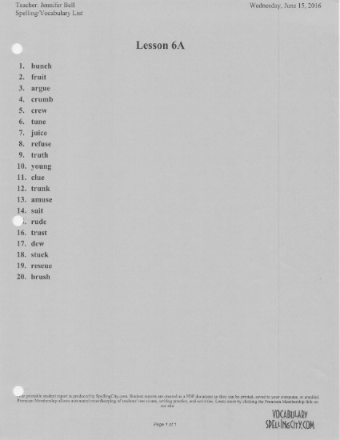

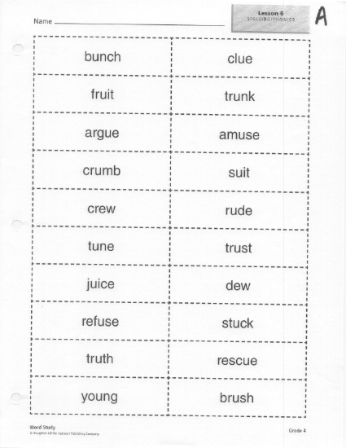

NAME______________________
Test 6A
Choice Strategy
1 | - Brunch  - Bunch
2 | - Froot  - Fruit
3 | - Argue  - Argew
4 | - Crum  - Crumb
5 | - Kru  - Crew
6 | - Toon  - Tune
7 | - Juice  - Joose
8 | - Refuse  - Refuze
9 | - Truth  - Tooth
10 | - Yung  - Young
11 | - Cloe  - Clue
12 | - Trunck  - Trunk
13 | - Amuze  - Amuse
14 | - Soot  - Suit
15 | - Rood  - Rude
16 | - Trust  - Trusd
17 | - Due  - Dew
18 | - Stuk  - Stuck
19 | - Rescue  - Rescew
20 | - Bruch  - Brush

Choice Strategy
NAME______________________
Test 6A
Yes/No Strategy
brunch | YES (or) NO
froot | YES (or) NO
argue | YES (or) NO
crumb | YES (or) NO
crew | YES (or) NO
toon | YES (or) NO
juice | YES (or) NO
refuse | YES (or) NO
truth | YES (or) NO
young | YES (or) NO
clue | YES (or) NO
trunck | YES (or) NO
amuse | YES (or) NO
sute | YES (or) NO
rude | YES (or) NO
trust | YES (or) NO
due | YES (or) NO
stuck | YES (or) NO
rescue | YES (or) NO
brush | YES (or) NO

Yes/No Strategy
NAME______________________
Spelling Test 6A

- _____________________
- _____________________
- _____________________
- _____________________
- _____________________
- _____________________
- _____________________
- _____________________
- _____________________
- _____________________
- _____________________
- _____________________
- _____________________
- _____________________
- _____________________
- _____________________
- _____________________
- _____________________
- _____________________
- _____________________
Open Ended Strategy

