NAME______________________
Lesson 5A
Spelling Test – Fill in the missing letters for the correct spelling of each word below.

- _ai _
- _ei_ _ _
- _ea_ _
- _e_ _
- _a_ _
- _a_e
- _ee_
- _ea_
- _ea_
- _ee_
- _e_ _
- _e_ _
- _ _e_ _
- _ee_
- _ea_
- _ai_
- _a_e
- _ei_
- _i_e_
- _i_o_

Closed Strategy – Consonant Elimination

NAME______________________
Lesson 5A
Spelling Test – Fill in the missing letters for the correct spelling of each word below.

- w_ _t
- w_ _ght
- h_ _rd
- h_rd
- d_ys
- d_z_
- h_ _l
- h_ _l
- p_ _k
- p_ _k
- s_ nt
- c_nt
- sc_nt
- f_ _t
- f_ _t
- v_ _n
- v_n_
- v_ _n
- m_n_r
- m_n_r

Closed Strategy – Vowel Elimination

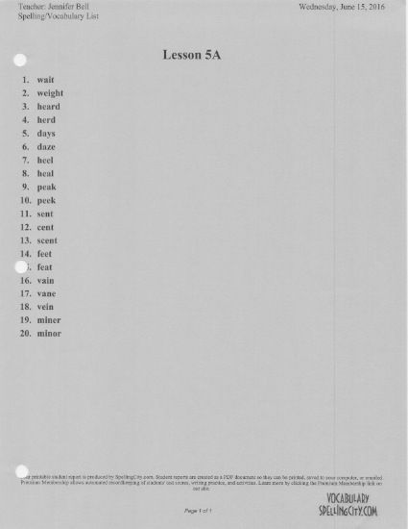

NAME______________________
Test 5A Choice
Choice Strategy
1. | - Wait  - Weight
2. | - Wait  - Weight
3. | - Heard  - Herd
4. | - Heard  - Herd
5. | - Days  - Daze
6. | - Days  - Daze
7. | - Heel  - Heal
8. | - Heel  - Heal
9. | - Peak  - Peek
10. | - Peak  - Peek
11. | - Sent  - Cent  - Scent
12. | - Sent  - Cent  - Scent
13. | - Sent  - Cent  - Scent
14. | - Feet  - Feat
15. | - Feet  - Feat
16. | - Vain  - Vane  - Vein
17. | - Vain  - Vane  - Vein
18. | - Vain  - Vane  - Vein
19. | - Minor  - Miner
20. | - Minor  - Miner

Choice Strategy
NAME______________________
Spelling Test 5A
- _____________________
- _____________________
- _____________________
- _____________________
- _____________________
- _____________________
- _____________________
- _____________________
- _____________________
- _____________________
- _____________________
- _____________________
- _____________________
- _____________________
- _____________________
- _____________________
- _____________________
- _____________________
- _____________________
- _____________________

Open Ended Strategy
NAME______________________
Test 5A
Yes/No Strategy
weight | YES (or) NO
wait | YES (or) NO
heard | YES (or) NO
herd | YES (or) NO
days | YES (or) NO
daze | YES (or) NO
heel | YES (or) NO
heal | YES (or) NO
peak | YES (or) NO
peek | YES (or) NO
scent | YES (or) NO
cent | YES (or) NO
sent | YES (or) NO
feet | YES (or) NO
feat | YES (or) NO
vain | YES (or) NO
vane | YES (or) NO
vein | YES (or) NO
miner | YES (or) NO
minor | YES (or) NO
Yes/No Strategy

