NAME______________________
Lesson 4A
Spelling Test – Fill in the missing letters for the correct spelling of each word below.

- _ _o_ _
- _ _o_ _
- oa_ _ea_
- _ _o_e
- _e_ _o_
- _ _o_ _
- _oa_ _
- o_ _
- _o_a_e
- _ _o_e
- _ _ _oa_
- _o_ _
- o_ _i_e
- _ _o_ _
- _o_ _e
- _ _o_ _
- _e_o_e
- _ _o_ _
- _oa_ _
- _ _o_e

Closed Strategy – Consonant Elimination

NAME______________________
Lesson 4A
Spelling Test – Fill in the missing letters for the correct spelling of each word below.

- bl_ck
- sh_wn
- _ _tm_ _l
- wr_t_
- f_ll_w
- sc_ld
- c_ _st
- _dd
- l_c_t_
- sl_p_
- thr_ _t
- h_st
- _nl_n_
- sh_ck
- s_lv_
- kn_wn
- r_m_v_
- st_ck
- b_ _st
- gl_b_

Closed Strategy – Vowel Elimination
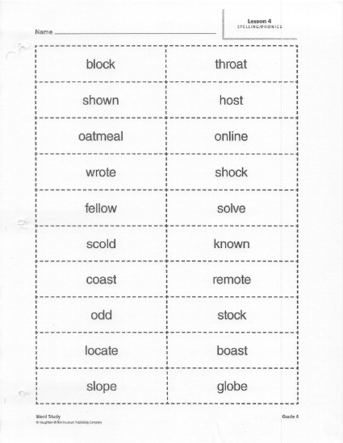

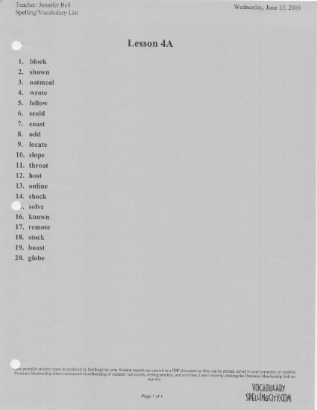

NAME______________________
Spelling Test 4 A
- _____________________
- _____________________
- _____________________
- _____________________
- _____________________
- _____________________
- _____________________
- _____________________
- _____________________
- _____________________
- _____________________
- _____________________
- _____________________
- _____________________
- _____________________
- _____________________
- _____________________
- _____________________
- _____________________
- _____________________
Open Ended Strategy
NAME______________________
Test 4 A
Choice Strategy
Choice Strategy
1 | - Block  - Black
2 | - Shawl  - Shown
3 | - Oatmeel  - Oatmeal
4 | - Wrote  - Write
5 | - Feelo  - Fellow
6 | - Skold  - Scold
7 | - Cost  - Coast
8 | - Odd  - Od
9 | - Locate  - Lokate
10 | - Slop  - Slope
11 | - Throte  - Throat
12 | - Hast  - Host
13 | - Online  - Onlin
14 | - Schock  - Shock
15 | - Solve  - Salve
16 | - Nown  - Known
17 | - Remoat  - Remote
18 | - Stock  - Stok
19 | - Bost  - Boast
20 | - Glob  - Globe

Choice Strategy
NAME______________________
Test 4A
Yes/No Strategy
block | YES (or) NO
shown | YES (or) NO
oatmeel | YES (or) NO
write | YES (or) NO
fellow | YES (or) NO
scold | YES (or) NO
coast | YES (or) NO
od | YES (or) NO
locate | YES (or) NO
slop | YES (or) NO
throat | YES (or) NO
host | YES (or) NO
online | YES (or) NO
shok | YES (or) NO
solve | YES (or) NO
nown | YES (or) NO
remote | YES (or) NO
stock | YES (or) NO
boast | YES (or) NO
globe | YES (or) NO
Yes/No Strategy

