NAME______________________
Lesson 3A
Spelling Test – Fill in the missing letters for the correct spelling of each word below.

- _ _i_ _
- _ _i_e
- _ _i_ _
- _o_i_ _ _
- _ _ i_ _
- _ _i_ _ _
- _i_e
- _ _i_ _
- _e_i_ _ _
- _ui_ _
- _i_ _ _
- _e_i_e
- _i_ _e_ _
- _i_ _
- _i_ _ _i_ _
- i_ _ _
- _i_ _
- _ _i_ _ _
- _e_i_ _
- _ _ _i_

Closed Strategy – Consonant Elimination
NAME______________________
Lesson 3A
Spelling Test – Fill in the missing letters for the correct spelling of each word below.

- sk_ll
- cr_m_
- gr_nd
- t_n_ght
- br_ck
- fl_ght
- l_v_
- ch_ll
- d_l_ght
- b_ _ld
- d_tch
- d_c_d_
- w_tn_ss
- w_nd
- d_str_ct
- _nch
- s_gh
- fr_ght
- r_m_nd
- spl_t

Closed Strategy – Vowel Elimination
1.________________________________
NAME______________________
Spelling Test – Spell each word after you hear them.

2.________________________________

3.________________________________

4.________________________________

5.________________________________

6.________________________________

7.________________________________

8.________________________________

9.________________________________

10._______________________________

Open Ended Strategy
11.____________________________________

12.____________________________________

13.____________________________________

14.____________________________________

15.____________________________________

16.____________________________________

17.____________________________________

18.____________________________________

19.____________________________________

20.____________________________________

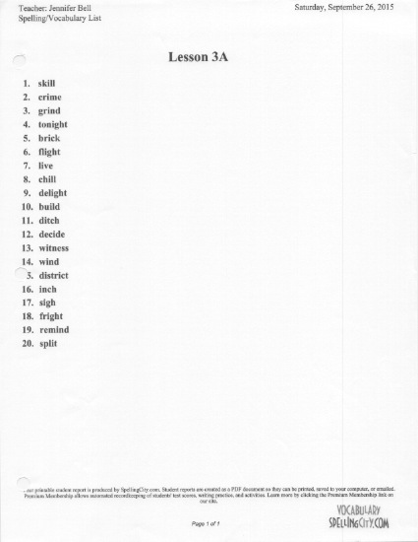

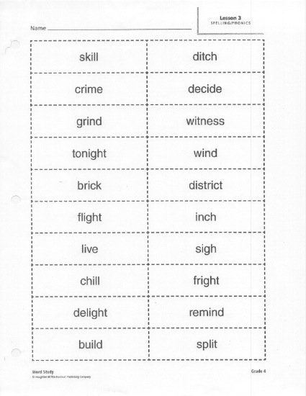

- Skill skell
NAME______________________
Spelling Test – Circle the correct spelling of each word below.
- Cryme crime
- Gind grind
- Tanite tonight
- Brik brick
- Flight flite
- Live life
- Chull chill
- Delite delight
- Build built
- Dich ditch
- Decide deside
- Witness whiteness
- Winde wind
- District districk
- Inche inch
- Sighe sigh
- Fright frite
- Reemind remind
- splite split

Choice Strategy

NAME______________________
Spelling Test – Circle Yes or No for if correct spelling of each word is shown below.
- Skill Yes No
- Cryme Yes No
- Grind Yes No
- Tanite Yes No
- Brick Yes No
- Flight Yes No
- Live Yes No
- Chull Yes No
- Delight Yes No
- Build Yes No
- Dich Yes No
- Decide Yes No
- Witness Yes No
- Wind Yes No
- District Yes No
- Inche Yes No
- Sighe Yes No
- Fright Yes No
- Reemind Yes No
- Split Yes No

Yes/No Strategy

