NAME______________________
Lesson 2A
Spelling Test – Fill in the missing letters for the correct spelling of each word below.

- _e_ _
- _ _ee_
- _e_ _e_
- _ _ea_
- _ _e_ _
- _ _ee_o_
- _ _ee_
- _ _ea_
- _ea_ _
- _e_ie_e
- _ _e_ _
- _e_ _
- _ _ea_
- _ _e_e_ _
- _ _ee_
- _ _e_ _
- _ea_ _
- ea_e_
- _ea_o_
- _ _ie_

Closed Strategy – Consonant Elimination
NAME______________________
Lesson 2A
Spelling Test – Fill in the missing letters for the correct spelling of each word below.

- w_st
- st_ _ p
- m_mb_r
- gl_ _m
- fr_sh
- fr_ _d_m
- sp_ _d
- st_ _m
- b_ _st
- b_l_ _v_
- sp_ck
- k_pt
- ch_ _p
- pr_t_nd
- gr_ _d
- sh_lf
- l_ _st
- _ _g_r
- r_ _s_n
- ch_ _f

Closed Strategy – Vowel Elimination
1.________________________________

2.________________________________

3.________________________________

4.________________________________

5.________________________________

6.________________________________

7.________________________________

8.________________________________

9.________________________________

10._______________________________

Open Ended Strategy

NAME______________________
Spelling Test – Spell each word after you hear it.
11.____________________________________

12.____________________________________

13.____________________________________

14.____________________________________

15.____________________________________

16.____________________________________

17.____________________________________

18.____________________________________

19.____________________________________

20.____________________________________

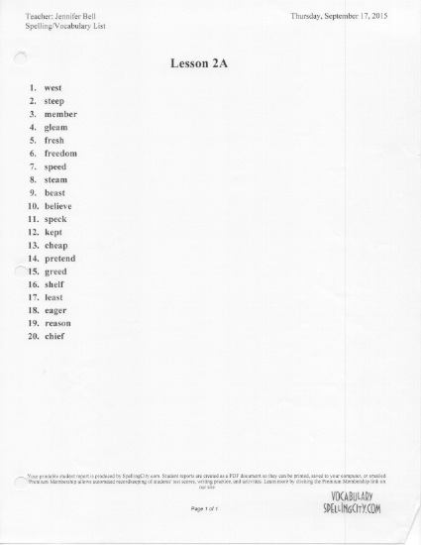

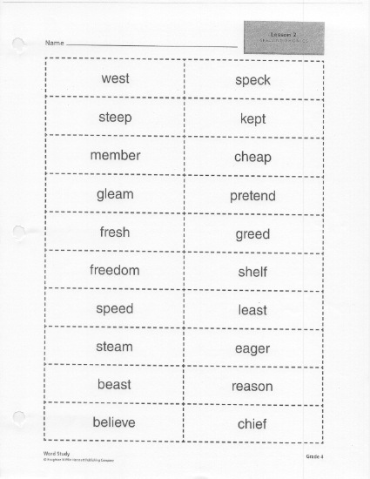

- West wist
NAME______________________
Spelling Test- Circle the correct spelling of each word below
- Steap steep
- Member member
- Gleam gleem
- Fresh freshe
- Fredomm freedom
- Spead speed
- Stream steam
- Beest beast
- Believe bilieve
- Spek speck
- Kept cept
- Cheep cheap
- Pretend pretend
- Greed gread
- Shelf self
- Leest least
- Eegar eager
- Reason reeson
- Chief cheef

Choice Strategy
- west
NAME______________________
Spelling Test – Circle yes or no if the correct spelling of each word is below.
YES NO
- steap
YES NO
- membar
YES NO
- gleam
YES NO
- fresh
YES NO
- fredomm
YES NO
- spead
YES NO
- stream
YES NO
- beest
YES NO
- believe
YES NO

Yes/No Strategy
- spek
YES NO
- kept
YES NO
- cheep
YES NO
- pretand
YES NO
- greed
YES NO
- shelf
YES NO
- leest
YES NO
- eegar
YES NO
- reason
YES NO
- chief
YES NO

