Name ______________________
Lesson 1A
Spelling Test – Fill in the missing letters for the correct spelling of each word below.

- _ _a_e
- _ _a_
- _a_ _
- a_ _ai_
- _a_i_
- _e_a_
- a_a_e
- _ _ai_
- _a_ _e
- _ _ea_
- _a_e
- _a_ _
- _ _ai_
- _ _a_ _
- _a_ _
- _ai_
- _ _a_o_
- _a_ _
- _ _a_e
- _ _ea_

Closed Strategy-Consonant Elimination

Name ______________________
Lesson 1A
Spelling Test – Fill in the missing letters for the correct spelling of each word below.

- bl_d_
- gr_y
- p_st
- _fr_ _d
- m_g_c
- d_l_y
- _m_z_
- dr_ _n
- m_yb_
- br_ _k
- s_l_
- h_ng
- st_ _n
- gl_ss
- r_ft
- j_ _l
- cr_y_n
- f_ct
- st_l_
- st_ _k

Closed Strategy-Vowel Elimination

Name ______________________
Spelling Test – Spell each word after you hear it.
1.________________________________

2.________________________________

3.________________________________

4.________________________________

5.________________________________

6.________________________________

7.________________________________

8.________________________________

9.________________________________

10._______________________________

Open Ended Strategy

11.____________________________________

12.____________________________________

13.____________________________________

14.____________________________________

15.____________________________________

16.____________________________________

17.____________________________________

18.____________________________________

19.____________________________________

20.____________________________________

Name ______________________
Spelling Test – Spell each word after you hear it.
1.________________________________

2.________________________________

3.________________________________

4.________________________________

5.________________________________

6.________________________________

7.________________________________

8.________________________________

9.________________________________

10._______________________________

Open Ended Strategy

11.____________________________________

12.____________________________________

13.____________________________________

14.____________________________________

15.____________________________________

16.____________________________________

17.____________________________________

18.____________________________________

19.____________________________________

20.____________________________________

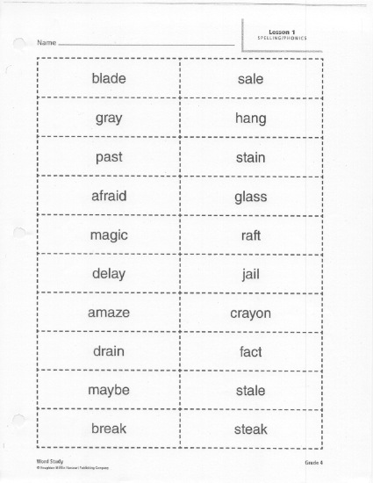

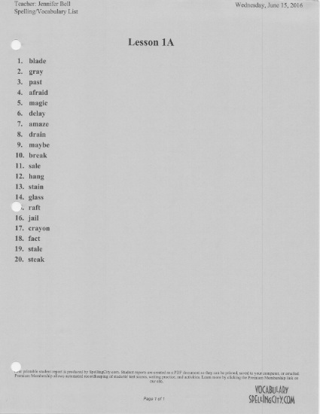

- blaed blade
Name ______________________
Spelling Test – Circle the correct spelling of each word below.
- gray graye
- past pest
- affraid afraid
- magic majic
- delay dalay
- ammaze amaze
- drain drein
- maybe maybay
- braek _ break
- sale salle
- hung hang
- staine stain
- glasse glass
- raft _ reft
- jial jail
- crayen crayon
- fact fect
- stale still
- stick steak

Choice Strategy

- Blade
Name ______________________
Spelling Test – Circle yes or no if the correct spelling of each word is below.
YES NO
- Graye
YES NO
- Paste
YES NO
- Afraid
YES NO
- Magic
YES NO
- Dellay
YES NO
- Amaze
YES NO
- Draine
YES NO
- Maybe
YES NO
- Break
YES NO

Yes/No Strategy
- Sale
YES NO
- Hung
YES NO
- Staine
YES NO
- Glass
YES NO
- Reft
YES NO
- Jail
YES NO
- Crayon
YES NO
- Fect
YES NO
- Stail
YES NO
- Steak
YES NO

