Getting your departments CPC site ready for submission
If you are currently using this site for your department to review the file you are able to delete the faculty members of your department and add the CPC members for review. You do not need to transfer files to a separate Blackboard site.
To finish the process, you will need to remove prior semesters members and add current semesters members.
How to remove past members
1) In Blackboard, (http://mybb.gvsu.edu) find your My Organization Plus module
2) Click Edit Users on the right side of the BB site name
3) Check the box on the left side, under the light grey Unenroll column, of the participants that are not involved this semester.
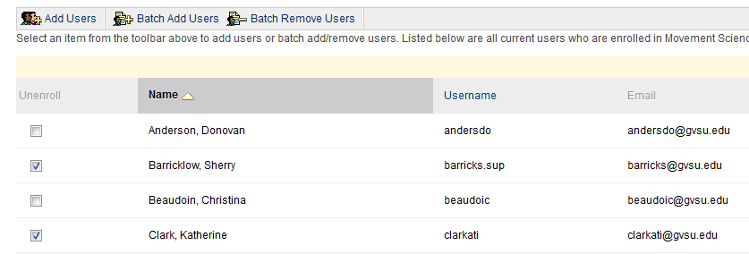
4) After the names have been selected scroll the bottom right and click submit

How to add the new CPC Committee members
1) In Blackboard, (http://mybb.gvsu.edu) find your My Organization Plus module
2) Click Edit Users on the right side of the BB site name
3) Click Add Users
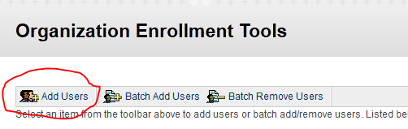
4) Copy the user names that you receive that are not on your list. (It will NOT let you duplicate users.) When adding members for review, add them as participants only.
*Please contact Heidi for current CPC members.
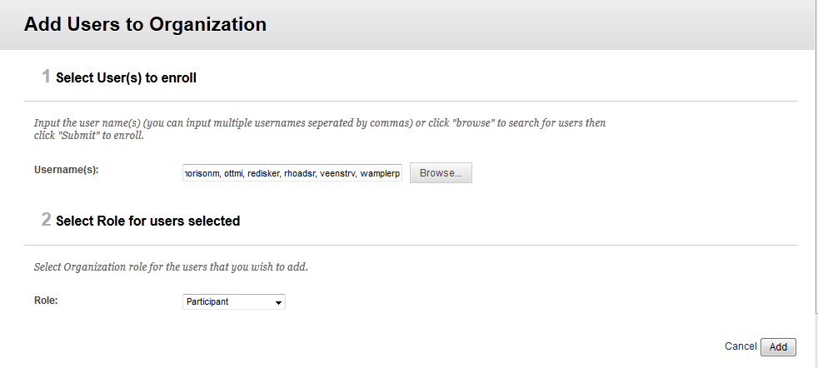
5) Click Add
6) Scroll down and you will see a list of the users that were successfully added

