AP Salary & Benefits Subcommittee Meeting
Thursday, November 13, 2014
Location: JZH 1012

Present: Linda Yuhas, Dave Smith, Susan Proctor, Julie Amon, Michelle Cronk and Luanne Brown

Old Business

- Vacation Time Per Years of Service – Dave Smith
  - Dave Benchmarked GVSU against other Universities and Business and found:
    - Our policy of accruing 20 days (160 hours) + the paid holiday break and holiday per year is a very robust plan as compared to others and is in line with other Michigan Universities
    - The outlier was Northern Michigan – with 37 days they may need to offer more to include “snow days” and to also attract potential employees to the UP.
    - The option to “purchase” more vacation days was brought up but something we have not pursued. Only 4% of the employers in all industries offered this benefit and it has a lot of administrative costs and compliance involved.

- Senior Academic Positions – Linda Yuhas.
  - Follow up on the final criteria that issued on August 8, 2014 (Scanned copy in email)
  - Addressed concerns on what is the promotion process for academic departments
    - To request a promotion/title change you must follow the HR process which involved the “hiring approval form” and the “justification for promotion form”.
    - The forms are routed through the different approval office before the change is made.
  - Discussion on can a promotion take place before a raise or do they have to happen at same time? Linda Y said the majority of changes happen at the same time (August 8th) and on very rare occasions someone may get a title change but not a raise until August.

Updates from Dave Smith:

- United Bank HSA – An AP staff member asked about the possibility of having investment options for our HSA accounts instead of earning the base interest. This was spurred by that fact that the interest rate dropped from 3% to the chart below.
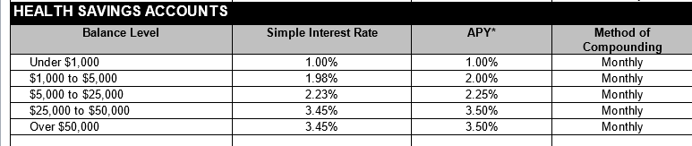
- Dave has been working with United to see what options are available and all that were presented have large fees attached because of broker chargers. Dave did mention that employees can decide to roll over the money in their HSA account if they set up another HSA account without any penalties. There are individual HSA plan available that allow you to invest your money in the market. Employees should be aware of the fees involved if they do choose to do this on their own.

- Open Enrollment – Open enrollment went very well this year with over 93% of the benefit eligible employees taking part. The volume of follow up calls to benefits from employees has been very low. Communication was constant and reminder emails went out at least 5 times. It was noted that the video was very helpful which included information on retirement. Reminder to staff that supplemental contributions to retirement is a separate process and not handled through open enrollment.

The Retirement Presentation was postponed due to technical difficulties with the equipment in the room. This will be rescheduled to next month if we do not have any other speaker booked.

Committee commented that the Healthy Office Grants through Health and Wellness are a hit. Promote coming up with unique ideas that are health and wellness related. It was discussed that the wellness grants are for smaller items and projects. If offices are looking at furniture modification such as adjustable desks then those need to go through your individual departments and facilities.

Healthy Choices Program will be rolled out in January with new incentives including spouses and/or dependents.

Change of April meeting to April 23rd from the 16th due to AP luncheon.

