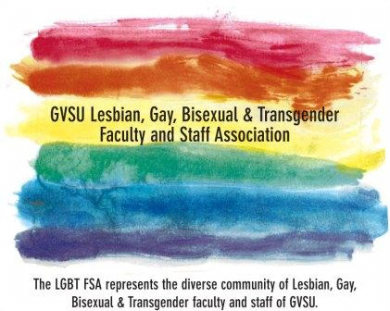**PRISM AWARD**

***Nomination Form***

The PRISM AWARDS were created to acknowledge GVSU faculty, staff, or administration who create a positive, healthy environment for the LGBT community on campus. We are looking for YOUR INPUT on nominees to receive the next PRISM AWARD(S). Recipients will be recognized each year.

To nominate a colleague/individual/group that you think has worked and committed to creating a safe, productive LGBT environment at GVSU, please fill out the following information:

Your name:

Your email:

Extension:

Your relationship to nominee:

Nominee name:

Nominee title/department:

Nominee email:

Extension:

**What makes this person a *strong candidate/nominee*?**

**How does this person *positively contribute to the LGBT climate* on GVSU’s campus?**