Epigenetic adaptation in plants to rapid climate change – sampling instructions for
Dryas integrifolia and Dryas octopetala
Please find below a brief description of our project as well as the sampling protocol.

The world’s climate is warming at an unprecedented rate. Can plants adapt fast enough to keep up? Will they adapt through the slow accumulation of favourable genetic changes or through more rapid, but less stable, changes in DNA methylation and related processes, broadly termed epigenetic adaptation?

We will use artificially warmed plots at International Tundra Experiment (ITEX) sites across the Arctic to determine the mechanisms and speed of plant adaptation to climate change. Experimental warming at ITEX sites using standardized open-top chambers (OTCs) has been maintained in tundra communities for up to 27 years. This provides a unique opportunity to study short-term adaptive responses to climate warming. Our focus will be on Mountain Aven (Dryas integrifolia and Dryas octopetala), which germinates easily and has a small genome, making it an ideal plant to study. We will sequence plants from the warmed and control plots across the ITEX sites to identify differences in DNA methylation that are consistently associated with artificial warming. We will examine the methylation patterns in the offspring of the wild plants grown in a controlled environment common garden to determine if the environmentally induced epigenetic methylation patterns can be passed onto future generations.

This unique study will enable us to begin to test the mechanisms, inheritance and speed of plant adaptation to climate change. We will deliver (1) a first assessment of the importance of epigenetic changes to climate change adaptation; and (2) a white paper that offers guidance to policy makers as to whether plants will adapt fast enough to cope with climate change or whether intervention will be necessary.

If you are able to help with this project by providing dried live leaf and seed samples from approximately 40 plants (or as many as possible: 20 from OTCs and 20 from controls) from your site, you will be included as a co-author on any papers we may publish.

Materials
After you agree to participate, we will send you a package containing the following:
- Enough silica for ~40 samples
- 40 leaf coin envelopes
- 40 seed coin envelopes
- 15 mL tubes for collecting frozen leaf samples
- A paper copy of this protocol
- Paper for recording site name, date collected, species, etc.
- Several large Ziploc bags containing silica
- Permanent marker

Sampling Protocol
(Adapted from Ruud Scharn’s ITEX synthesis protocol)

We will need dried leaf samples from 40 (or as many as possible) different plants at each site (20 plants from the OTCs and 20 from the controls). If your site is equipped with a freezer, it would be desirable (but not essential) to also include frozen samples. Please collect the leaf samples as described by the steps below. We will also need mature seeds from all individuals from which you collect leaf samples. Ideally, you would collect the seeds and leaves together, so sampling should begin when seeds are available.

- Begin outside the open-top chambers (OTCs).

- Find a Dryas integrifolia or D. octopetala plant that has set seed.

- Harvest green Dryas integrifolia or D. octopetala leaves from each plant (preferably green fresh leaves that look like they grew this year) (Fig. 1). Harvest as many leaves as possible without doing too much damage to the plant.
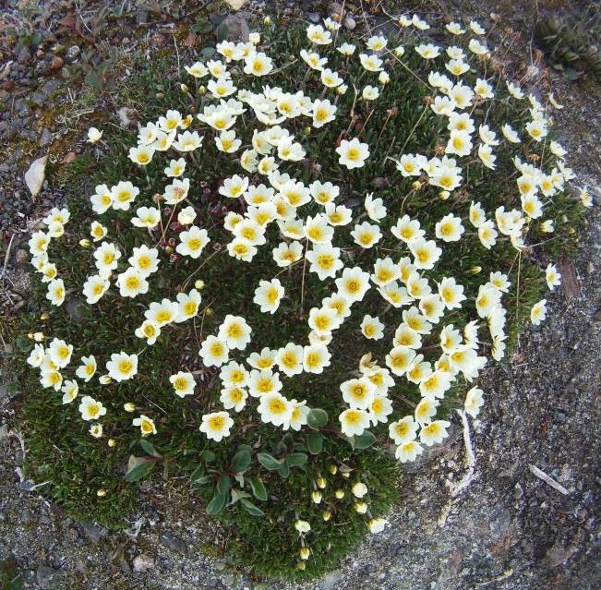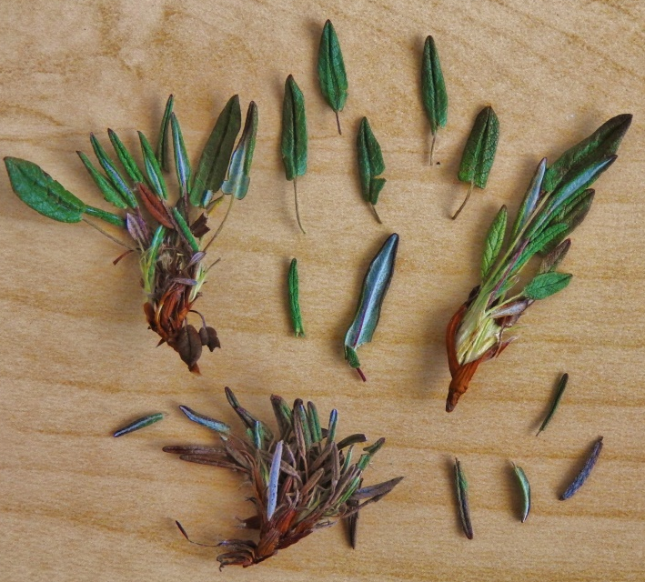
Figure 1: (left) Dryas integrifolia plant. (right) Dryas leaves sampled from one plant.

- Place ~20 leaves from the plant in one of the coin envelopes labeled “Lv #”.

- Take one seed head (the entire group of seeds) from the same plant you just sampled and put the seeds in the coin envelope labelled “Seeds #”. Try to pick the most ripe seed head available.

- Check that the numbers on the leaf and seed coin envelopes match and the plant materials come from the same plant.
- Place the coin envelopes containing the leaves and seeds back inside the Ziploc bag filled with silica (Fig. 2).
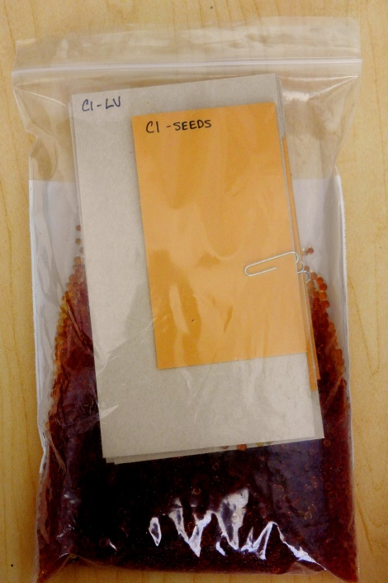
Figure 2: Coin envelopes containing the leaves and seeds from one plant in the silica.

- If you have a freezer at your site, fill the plastic tube that has an orange lid with another approx. 20 leaves. Label the tube with the treatment and number on the coin envelopes (Fig. 3).

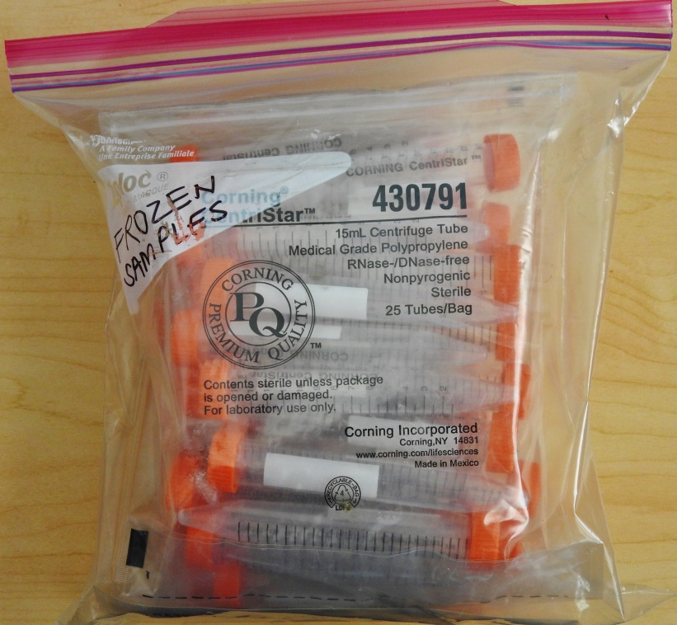
Figure 3: (left) Containers for leaf sample freezing. (right) A container full of Dryas leaves ready to be frozen.

- Continue steps 2 through 8 until all 20 samples (or as many as possible) have been collected outside the OTCs.

- Repeat steps 2 through 9 inside the OTCs. Begin by finding a Dryas integrifolia or D. octopetala plant that has set seed in the warming chambers. Continue steps 2 through 8 until all 20 samples (or as many as possible) have been collected inside the OTCs.

- Record your site’s name, latitude, longitude, date of collection, name of collector, and whether you collected D. octopetala or D. integrifolia on the larger Ziploc bags containing the samples or on a piece of paper included in one of the Ziplocs. If possible, also mark each smaller Ziploc bag with an abbreviation of your site’s name and the species you collected.

- Store the silica bag samples in a cool, dry, dark place until mailing. If possible, check the coloration of the leaves at regular intervals (e.g. every 2 days) for the next several days. If the leaves turn from green to brown, more silica should be added if possible.

- If you have collected freezer samples, store the orange lid tube samples in the site freezer until you depart from your site. Samples should then be transferred to a cooler with freezer packs and immediately mailed by couriering (including small cooler/freezer packs) to UBC. We will pay to have the samples sent and will return the cooler.

- Send the collected plant material to:
Greg Henry and Cassandra Elphinstone
Department of Geography
University of British Columbia
1984 West Mall
Vancouver, BC V6T 1Z2
CANADA
Questions should be send to: cassandra.elphinstone@shaw.ca

