UPWARD BOUND NEWSLETTER
Grand Valley State University
401 Fulton ST W, 396C DEV, Grand Rapids, MI 49504

October 2013
Contact Information  Administrative Office 616.331.3144  Innovation Central HS  616 819.6851  Room 125  Union HS 616.819.3843  Room 129  Ms. Smithalexander smithala@gvsu.edu  Mr. Brandsen  brandsjo@gvsu.edu  Ms. Dean  deanju@gvsu.edu  Ms. Tellez  telleze@gvsu.edu  (616) 589-1313  Spanish speaker  If you must contact a staff member, please do so only during office hours  8:00 AM – 5:00 PM | Community Project: Walk to Cure Diabetes  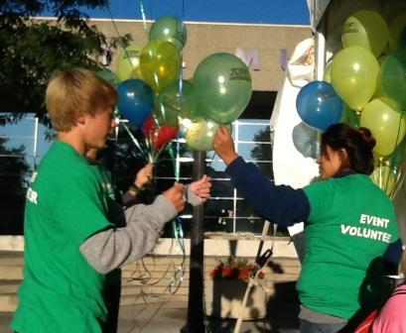  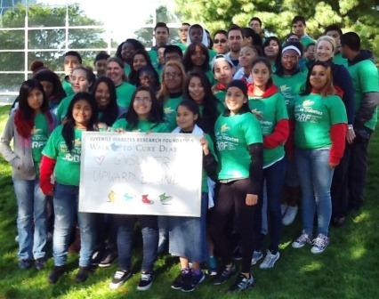  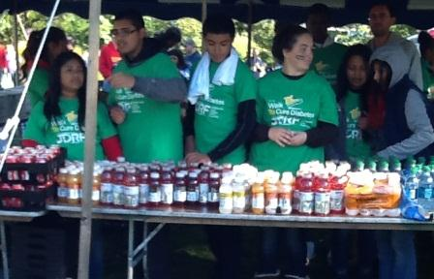  Thank you to all of the students and parents who participated in the Walk to Cure Diabetes community project on Saturday September 14th!  Marisa, Carlos, Brandon, Arlaina, Sophie, Rosa, Denise, Julio, Dominga, Laura, Cristian, Tatielle, Adrian, Diana, Antonio, Janelli, Mehdi, Yvonne, Elizabeth, Erika, Amber, Cecilia, Amber, Dahja, Fedrico, Oscar, Yuliana, Maria, Lucy, Janae, Victoria, Belinda, Ricardo, Diego, LaShaun, Murtaza.  WHAT WE DID IN SEPTEMBER  This was the 12th year that Upward Bound participated in the Juvenile Walk to Cure Diabetes.  Freshman Candidates  Upward Bound accepted 32 new freshman candidates into the program for the 2013-2014 school year. Eighteen (18) are students at Innovation Central; fourteen (14) are students at Union.  Dual Enrollment  Seven (7) seniors are in dual enrollment at Grand Rapids Community College. Four are enrolled in Math 110; one is enrolled in Sign Language; two are enrolled in Pre-Engineering.  After School Meetings/Tutoring Sessions  The after school meetings/tutoring sessions have begun. They are held immediately after school - at Union High School on Monday and Wednesday; at Innovation Central High School on Tuesday and Thursday.
SENIOR NEWS

College Representative Schedule:

Scholarship of the Month
Coca Cola Scholarship Due: October 31, 2013
INTERESTED APPLICANTS MUST BE:
- Current high school (or home-schooled) seniors in the United States;
- U.S. Citizens; U.S. Nationals; U.S. Permanent Residents; Temporary Residents (in a legalization program); Refugees; Asylees; Cuban-Haitian Entrants; or Humanitarian Parolees;
- Anticipating completion of high school diploma at the time of application;
- Planning to pursue a degree at an accredited U.S. college or university;
- Have a minimum 3.00 GPA at the end of their junior year of high school.

To apply go to:
http://www.coca-colascholars.org/

Union High School**

October 1 Cornerstone University
October 1 Michigan State University
October 4 Grand Valley State University
October 15 Western Michigan University
October 16 Eastern Michigan University
October 23 Central Michigan University
November 7 Northwood University
November 8 GVSU (on site admissions)

Innovation Central High School**

October 1 Grand Rapids Community College
October 2 Michigan State University
October 9 Northern Michigan University
October 23 Eastern Michigan University
October 24 University of Michigan
October 29 Aquinas College
**see counselor for exact time and room location
Michigan Public Universities Application Deadlines for Fall 2014

Eastern Michigan University *
January 15 - Priority Admission & Scholarship Consideration Deadline
July 1 - Fall Term Deadline
Northern Michigan University
Oct. 15 – Nov. 15 – Early Decision for Most Programs
Grand Valley State University
May 1 - Fall Term Deadline
Ferris State University
July 25 - Fall Term Deadline
Wayne State University
August 26 - Fall Term Deadline***
***Some programs may have earlier deadlines.
Michigan Technological University *
January 15 – Priority Application Due
University of Michigan
February 1 - Fall Term Deadline **
November 1 - Early Action (Freshmen Only)
** Deadline for School of Music, Theatre & Dance - December 1
University of Michigan Flint
November 15 – Fee Waived Deadline
August 19 – Fall Term Deadline
Michigan State University *
November 1 - Priority Admission & Scholarship Consideration Deadline
Western Michigan University *
December 3 - Priority Admission & Scholarship Consideration Deadline
Central Michigan University
December 1 - Priority Admission & Scholarship Consideration Deadline
July 25 – Fall Term Deadline

* Rolling admissions, but for maximum admission and scholarship consideration seniors are encouraged to apply by the deadlines above.

Meeting and Planning Community Projects

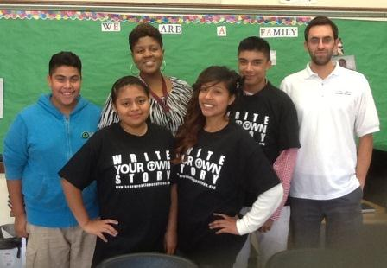
Planning the October Community Projects, Kent County Prevention Coalition (KCPC) staff met with students and staff at Innovation Central and Union High Schools to start planning Red Ribbon Week activities and Sticker Shock.

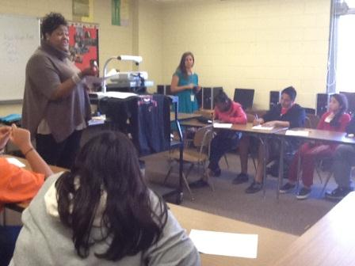
Top picture: Shannon Cohen with Mr. Brandsen and students at Innovation Central High School.

Bottom picture: Michelle Stitt with Ms. Dean and students at Union High School

October 16 | Sophomores garden planting at Kent County Trails
October 23-31 | Red Ribbon Week
October 26 | Project Sticker Shock, Saturday @ 9:30 AM
October Community Project Schedule

Volunteering in the community is an important part of the Upward Bound program. Students are required to volunteer 40 hours on their own and participate in 3 community projects per year. Students who do not complete and turn in their volunteer hours may not be able to attend the summer program, receive stipends in the summer, or be eligible to attend the summer cultural trip.

First Year Student Parent Meetings
Parents, please remember that if you did not attend the parent meeting you MUST schedule a meeting with UB staff. Please call our office (616-331-3144) to schedule an appointment as soon as possible. We will not accept you child as a candidate until we have met with you.

FUNDRAISERS

Parents – we are in the process of planning our first fundraiser of the year, which will be in October. You should hear from us next week to schedule the first parent planning meeting. We hope the first one will be a sub sale. Thank you for your support, all funds raised will go to the Upward Bound travel budget.

October 2013

Sunday | Monday | Tuesday | Wednesday | Thursday | Friday | Saturday
 |  | 1 | 2 | 3 | 4  Happy Birthday Khaleb! | 5
6 | 7 | 8 | 9 | 10 | 11  Happy Birthday Cierra! | 12
13 | 14 | 15 | 16  Sophomores at Kent County Trails 3:00-4:30 | 17  Happy Birthday Cheryl! | 18  Happy Birthday Dahja, Nathan and Marisela! | 19
20  Happy Birthday Alexis! | 21 | 22  Happy Birthday Diego! | 23  Red Ribbon Week Starts | 24  Happy Birthday Jaysen! | 25 | 26  Sticker Shock  Room 138E DEV  Pew Campus  9:30 AM
27 | 28 | 28 | 30 | 31  Happy Birthday Onemia and Jennifer!

