Sample Donation Support Request Letter 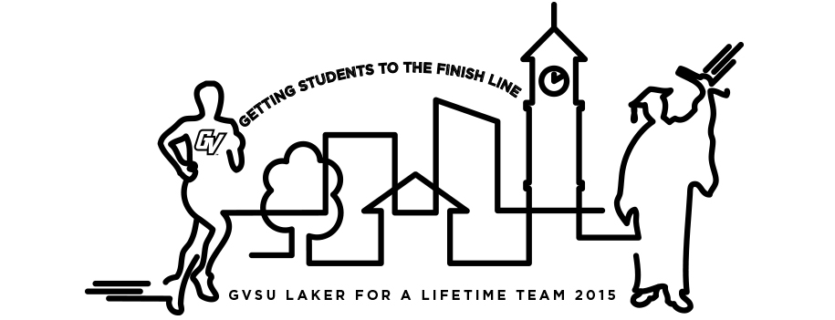
Dear Friends,
This spring I will be participating in the Fifth Third River Bank Run on May 9, 2015. As part of my participation in the event, I am partnering with Grand Valley State University as a member of the Laker for a Lifetime Team to help raise money for the GVSU Student Support Fund which provides emergency funds to students who face a financial crisis that could keep them from completing the necessary requirements to obtain a degree. The Student Support Fund is administered by financial aid to students who face the greatest need. The fund ensures a promising future to students who will go on to make a difference in society.
Whether you are a Laker or not, I ask that you will support my efforts by donating to this institution that provides an excellent education – one of the best in the Midwest. Helping a GVSU student improves his/her life, and in turn improves our community.
My goal is to raise _________________ before May 9, 2015.
Donations on my behalf can be made securely on my personal fundraising page at: _______________________ or you may also go to: www.gvsu.edu/give and designate your gift in my name. I will collect cash and checks as well; please make checks payable to Grand Valley State University with my name in the memo line.
If you are interested in learning more about the Grand Valley Fund or even participating with the team, you may find more information at www.gvsu.edu/alumni/rbr15 or contact a GVSU Alumni staff member at alumni@gvsu.edu or 800-558-0541.
Thank you for your support!
Sincerely,

