Ethnographic Field School
Summer 2015 Grand Valley State University
ANT 307: Field Techniques and Laboratory Methods in Anthropology
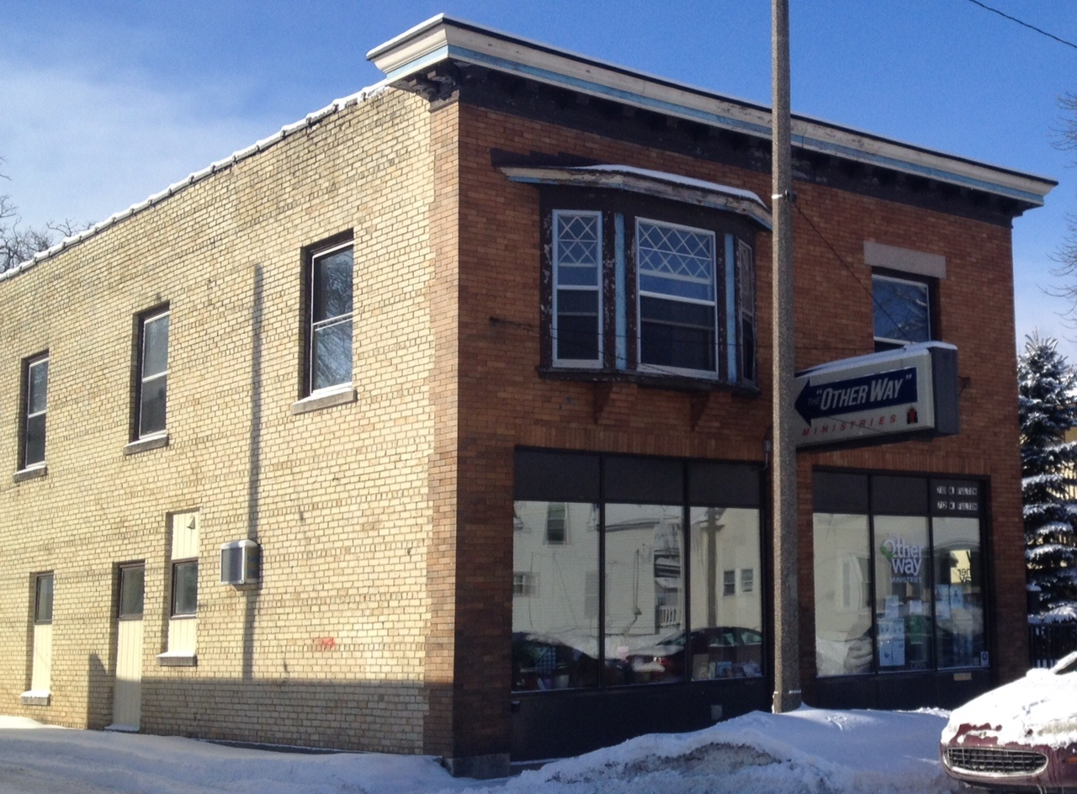
Health on the Westside of Grand Rapids
Dates May 4 – June 17, 2015
Times 3 credits: TR 10:00AM-3:50PM;
6 credits: MTWR 10:00AM-3:50PM

The Anthropology Summer Field School 2015 immerses students in daily life on the Westside of Grand Rapids and trains them in ethnographic field methods. Students will engage in hands-on research to apply anthropology in a meaningful way around issues related to community health. The field school will include the following interrelated and overlapping components:
- Classroom, focused on ethics and methods training, data analysis, and write-up
- Organizational, comprised of volunteer activities with a group, organization, or individual healthcare provider
      - Fieldwork, including participant-observation, and semi-structured and informal interviews

During the six-week field school, students will partner with The Otherway Ministries and the Westown Collaborative to gain an in-depth understanding of the needs, assets, motivations, and meanings related to community health among those living and working on the Westside.

To apply, use the attached application form and register mid-March, 2015

For more information, contact Dr. Tara Hefferan
224 Lake Michigan Hall, GVSU Anthropology, Allendale MI 49401; hefferta@gvsu.edu; 616/331-8924
Application DUE Thursday, March 19, 2015
GVSU Anthropology Ethnographic Field School
Spring 2015

Name_________________________________________ G #_________________________________

Birthdate__________ Gender__________ Anticipated date of graduation _____________ GPA_______

Academic Major(s)_______________________________ Minor(s) __________________________________

Local Address (include zip)_______________________________________________________________

Same address during field school? Y N: __________________________________________________

Local Phone___________________ Number field school credits you want to enroll for: 3 6

Have you taken a methods class? Y N (if yes, which one)____________________________________

Other courses you have taken that might be related (anthropology, sociology, health sciences, etc.):

Skills you have that might be related (data entry/analysis, mapping, photography, writing, employment/internship in health sector, second language, etc.):

Health-related research interests (if known):

Professor who can provide a recommendation for you: ________________________________________

Because we will be observing events and programs as they happen on the Westside, data collection will occur outside of the scheduled class time. Please mark your estimated availability during the spring semester in the schedule below (I realize it might change before the semester begins):

Day/Time | Monday | Tuesday | Wednesday | Thursday | Friday | Saturday | Sunday
8am
9am
10am
11am
12pm
1pm
2pm
3pm
4pm
5pm
6pm
7pm
8pm

On the back of this form, please explain in a brief paragraph why you are interested in participating in this field school.

Application Deadline: Thursday March 19, 2015 by 5:00 PM
Return to: Dr. Hefferan’s mailbox in the ANT office, 231 Lake Michigan or email to hefferta@gvsu.edu

